**Day 2 Lab Assignments**

**Use Bootstrap 5 (Assignments is** gray **color are optional for practice):**

1. Make simple Bootstrap page, and implement the following (Optional, if you can start with the following assignments):
   1. Try Container and container-fluid.
   2. Add an image and make it responsive and rounded.
   3. Add row with 6 rows and add an image in each row, and make it appear as thumbnail.
   4. Try any Bootstrap classes and components you need to try.
2. Make button that shows and hide any content (Use: element.classList.toggle()).
3. Make a page that contains login form contains username and password (Use Bootstrap forms), and on user Name input, when the user leaves the input check for the length of the entered text if less than 5 letters, show a bootstrap alert below the input saying “Name should be more than 5 letters” and when the text is valid close the alert.
   1. Make the alert dismissible (with close button).
   2. Use BS5 form validation
4. Design your online CV using the give template image (optional, if you can start with the next assignment).
   1. <https://www.w3schools.com/w3css/tryw3css_templates_cv.htm>
5. Design the following social media website template using Bootstrap:
   1. Make the navbar fixed and collapsible.
   2. Handle the layout of left, right and middle content to be columns 3,7,2 on the large and bigger screen, and to be columns 2,8,2 on the medium and smaller screens.
   3. Hide the profile image in small size (use d-none).
   4. Hide the right column in extra small screen.
   5. Handle mobile and tablet views according to the following demo:  
      <https://www.w3schools.com/w3css/tryw3css_templates_social.htm>

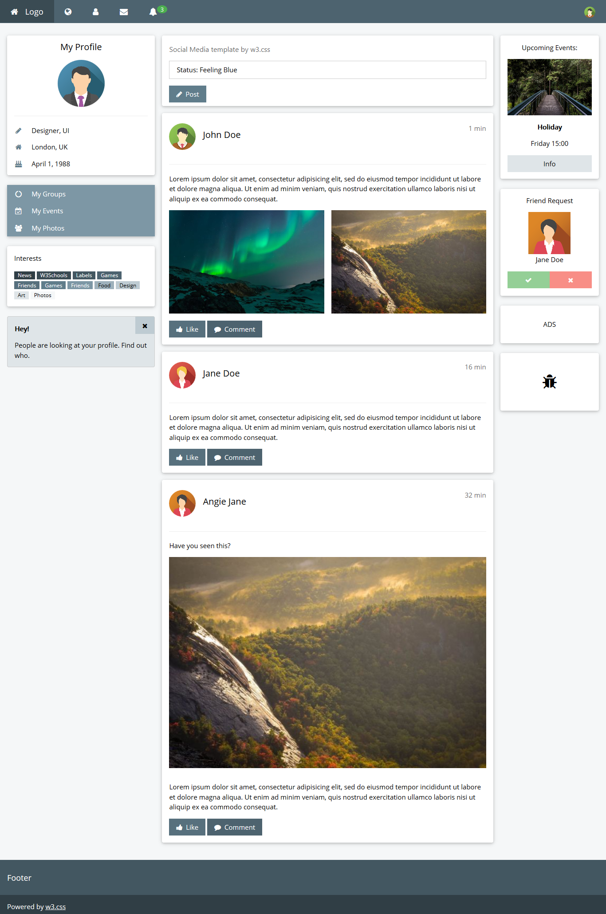

**Bonus:**

1. Design the following templates:
   1. <http://www.w3schools.com/w3css/tryw3css_templates_analytics.htm>
   2. <http://www.w3schools.com/w3css/tryw3css_templates_apartment_rental.htm>
   3. <http://www.w3schools.com/w3css/tryw3css_templates_dark_portfolio.htm>
   4. <http://www.w3schools.com/w3css/tryw3css_templates_clothing_store.htm>
   5. <http://www.w3schools.com/w3css/tryw3css_templates_bw_portfolio.htm>
2. Try other responsive frameworks (Foundation, Skelton, W3CSS,…), and compare it with Bootstrap.

**<Thank>YOU </Thank>**